Lab 6 Worksheet Earthquakes
Name ______ (-2 points if missing)
Date _______
Use your textbook, lab and lecture PowerPoints, and internet as needed to answer all questions in each of the 2 parts. Please explain everything in your own words.
Part 1
- Explain earthquake frequency on planet earth.

- Describe the type of movement experienced with P and S waves.

- What is the name of the process which is being demonstrated in the diagram below?
  - 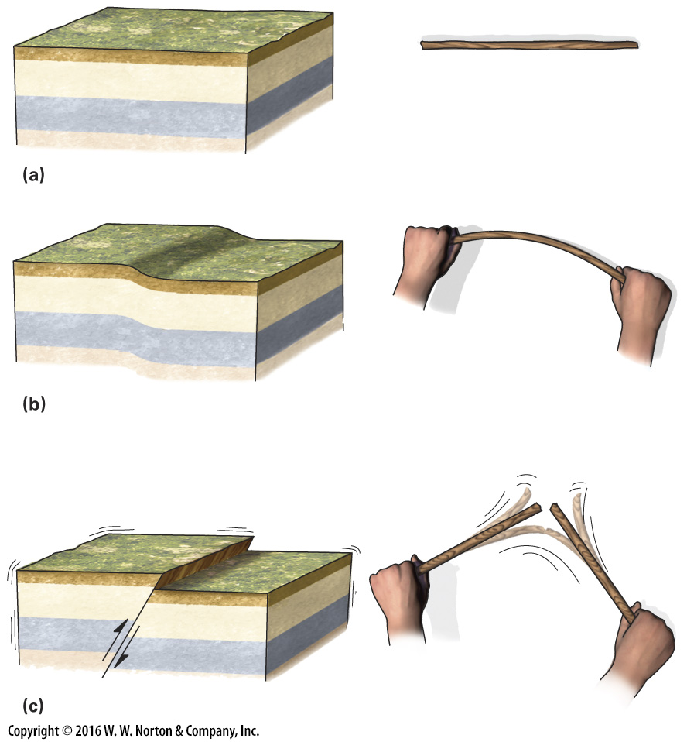

- Which plate boundary type experiences most of the biggest earthquakes on the planet?

- Explain why we need data from at least 3 seismic stations to pinpoint the location of an earthquake.

- Explain what is meant by amplification of earthquake waves through loose sediments compared to igneous rock?

- Where was the biggest earthquake ever recorded by humans, and what magnitude was it?

- Identify 4 of the many problems caused by earthquake?

Part 2
- How many more times shaking is there between a 5.0 and a 7.0 earthquake?

- How much more energy is released between a 5.0 and a 7.0 earthquake?

Use the following diagram to answer questions 11-13.
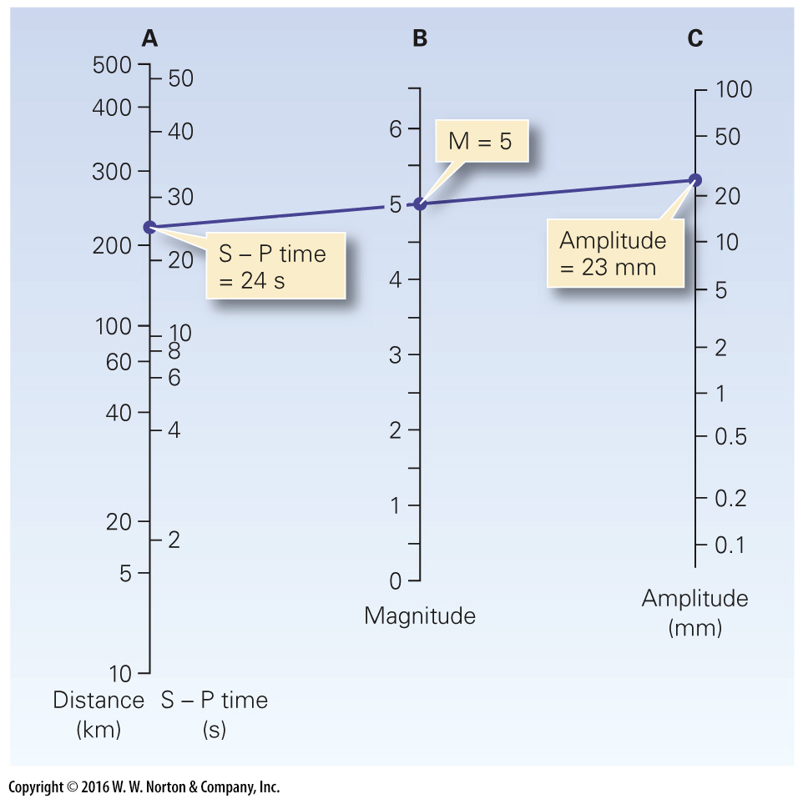
- If the amplitude is 0.5, and the magnitude of the quake is 4.3, what is the time difference between the P and S waves?

- If the earthquake is 100 miles from the seismic station, and the amplitude is 1 mm, what is the magnitude of the quake?

- If the amplitude is 100 mm, and the magnitude of the quake is 6.0. how far away from the seismic station was the quake?

- Below is an image from Anchorage, Alaska, after the 1964 earthquake. What was the magnitude of this quake?
  - 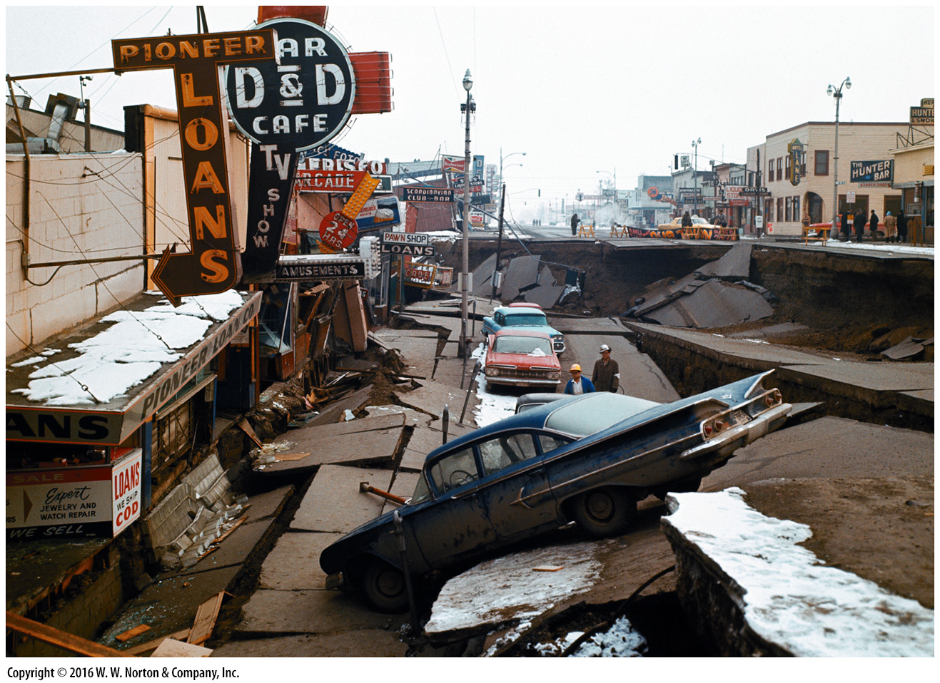

- From this same picture, how would you rate this quake on the Mercalli scale and why?

- Explain why an 8.0 moment magnitude earthquake on the mid-Atlantic rift at the equator would not have a rating on the Mercalli scale.

